Assignment 3 : Linux Commands

1. ls Display hidden files

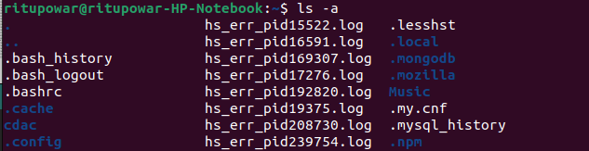

2. rename Rename all *.txt files to *.htm

3.ln -s Create symbolic link (shortcut) for a file

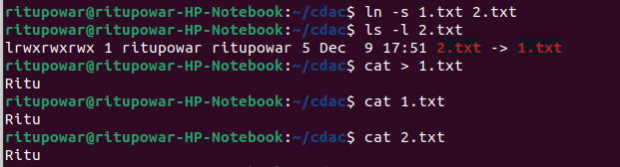

4.ln Create hard link for a file

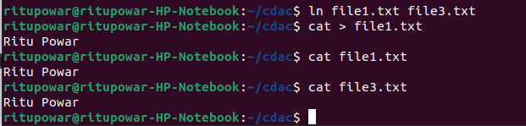

5.stat Display time stamp of the file

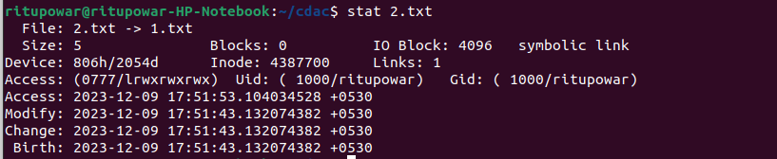

6.touch Change the time stamp of the file

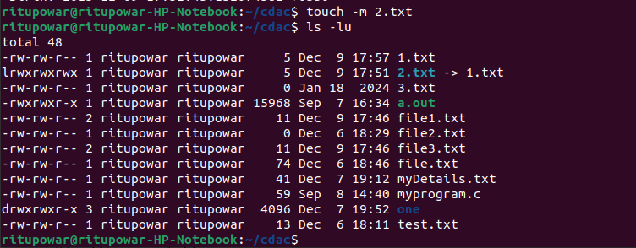
7. touch Create empty file

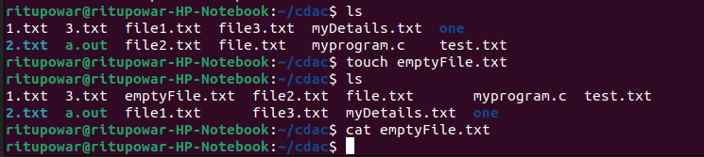

8. tail Print all lines in a file from fifth line onwards

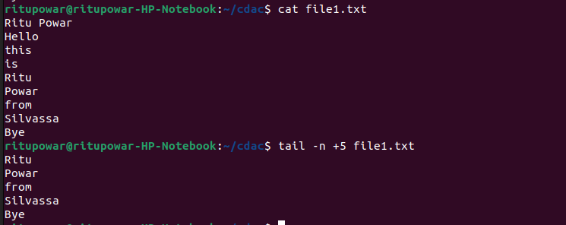

9. init 0, poweroffShutdown (Only for super-user)

10.init 6, rebootReboot (Only for super-user)

12. whoami Find current user

13.tty Find current terminal

14.whoami Find current user and terminal

15.users Find all users logged into the system

16.who Find all users logged in and terminals in use

17.grep, egrep, fgrep Find a given word/pattern from the file

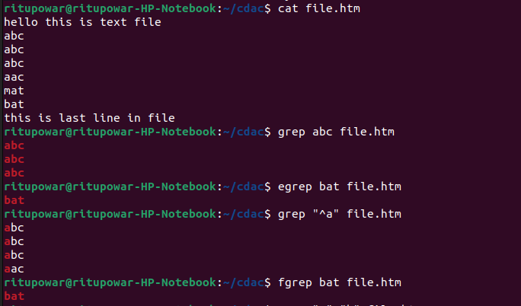

18.chmod Make a file as read-only

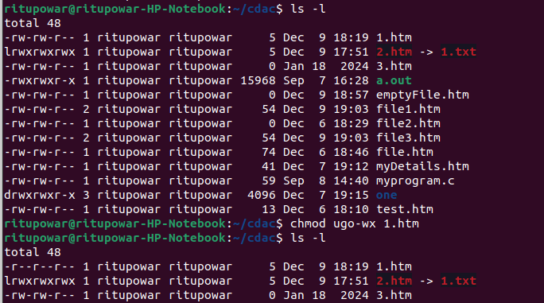

19.chmodMake a file as write, read and execute

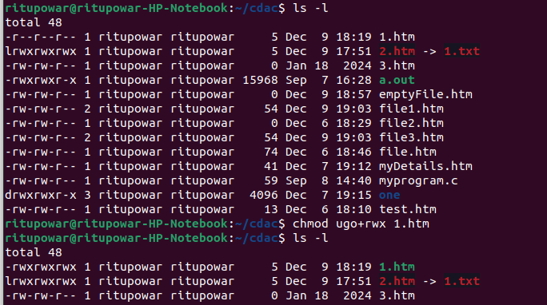

20.wc (using redirection)Take input from the file, count words and store output to other file

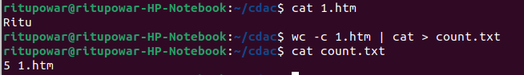

21. who | wc (using pipe)Count words in output of “who” command



22. head, tail (using pipe)Print lines 5 to 10 from the given file

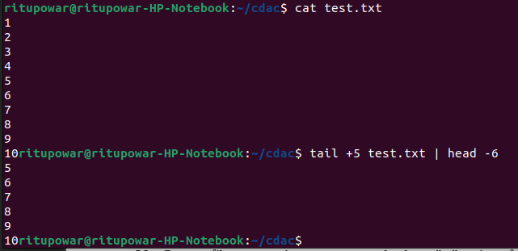

23.sort , uniq (using pipe)Print the uniq values from the unsorted file

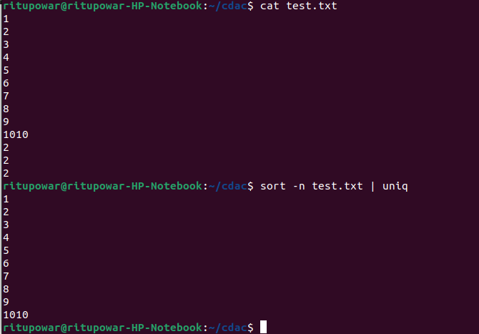

24.who, grep (using pipe)Display all users not using tty2, tty3, tty4

25.lsDisplay all files in ascending order of their file size


26.ls, grep (using pipe)Count number of files and directories from current directory

27.ls, grep (using pipe)Display only hidden files in a directory

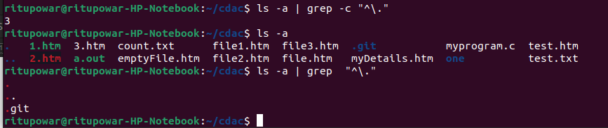

28.tr Convert file contents into uppercase , also learn "-s" option of this command

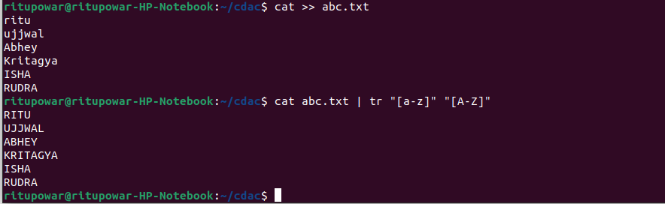

29.cut Split the file contents using delimiter and print required fields

